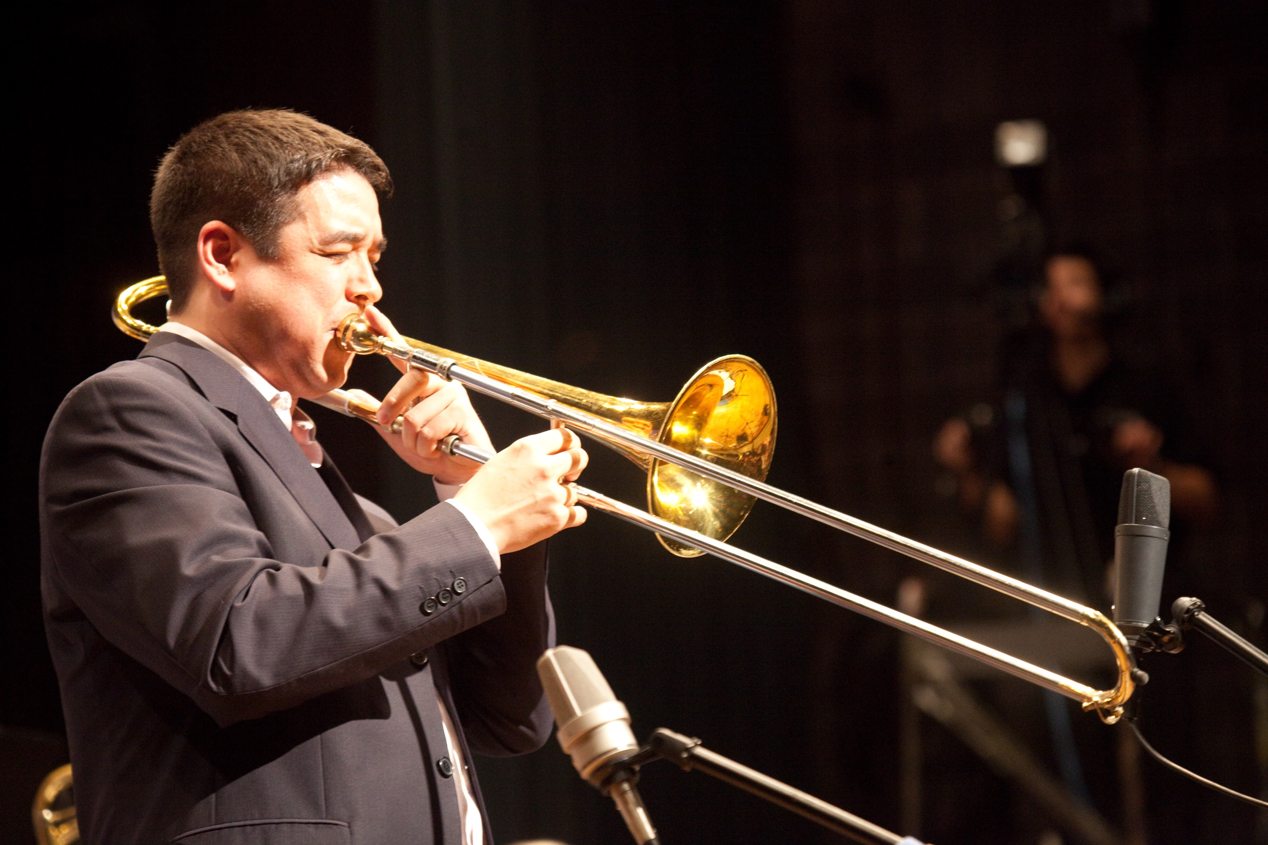

John Yao
Trombonist, Composer, Arranger
www.johnyao.com
john@johnyao.com

About John Yao

For over a decade, Yao’s adept skill as a trombonist, composer, arranger and bandleader have helped cement his place on the New York City jazz scene. As a trombonist, he has worked extensively as a sideman for Grammy-award winning ensembles such as the Vanguard Jazz Orchestra and the Afro-Latin Jazz Orchestra directed by Arturo O’Farrill, and has also performed with Paquito D’Rivera, Eddie Palmieri, Danilo Perez, Chris Potter and Kurt Elling among others. New York Music Daily wrote “John Yao is one of New York’s elite trombonists and is also a first-class, ambitious, and witty composer and leader.”

Yao is the leader of two working bands - John Yao Quintet and John Yao & His 17-piece Instrument. Both projects feature his adventurous compositions. Jazz Times says the John Yao Quintet 2012 recording In the Now “incorporate(s) an insistently swinging Jazz Messengers vibe while also stepping into the free-rider zone at times.” Midwest Record calls the John Yao & His 17-piece Instrument 2015 release Flip-Flop “a must set for big band fans that want to hear something that takes the form into the future, this blows the ears open in a mighty way.”

As a composer, he has been commissioned by professional ensembles such as the Afro-Latin Jazz Orchestra, Jazz Orchestra of Philadelphia directed by Terell Stafford, Band of Bones, Luis Bonilla’s I Talking too Big Band as well as writing for his own group, John Yao & His 17-piece Instrument. Yao has also written numerous commissions for college and high school ensembles around the world and was a member of the BMI Jazz Composers Workshop under the direction of Jim McNeely and Mike Holober. He founded the Big Band and Beyond Series featuring his large ensemble, John Yao and His 17-piece Instrument. The series aims to present and premier new compositions and deliver new sounds to big band. He currently lives in Jackson Heights, NY and everyday sets out to challenge himself daily as composer and a performer.

